**Group Project**

**Raw data type**

**Trd_co2**

**Trd_year2**

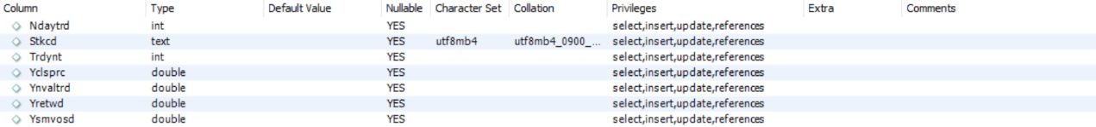

**Af_forecast2**

**ER Diagram**

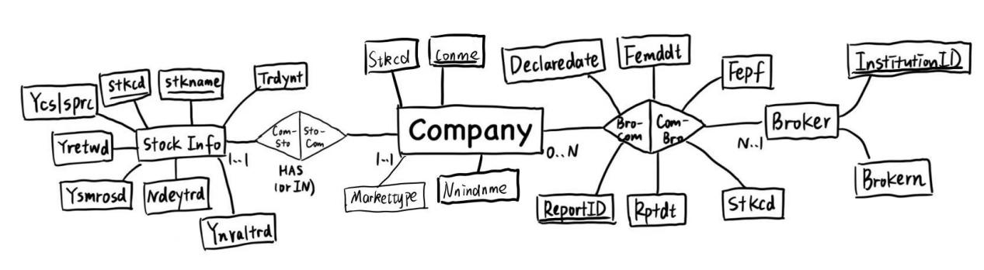

**Relation Data Model**

Company(Stkcd, Stknme, Nnindcd, Nnindnme,……)

Brokern(InstituitionID, Brokern)

Forecast(*Stkcd*, *InstituitionID*, Rptdt, Fenddt, DeclareDate, ReportID, Feps)

YearRR(*Stkcd*, Trdynt, Yretwd)

**SQL codes and query outputs**

1. Show a list of industries (Nnindcd, Nnindnme) and the number of listed firms in each industry based on 证监会2012版行业分类

**Code：**

CREATE VIEW firms_count (Nnindcd, Nnindnme, firms_count)

AS SELECT Nnindcd, Nnindnme, COUNT(*)

FROM trd_co2

GROUP BY Nnindcd, Nnindnme;

SELECT * FROM firms_count;

**Result：**

1. Show a list of brokerage firms (InstitutionID, Brokern) and the number of reports released by each brokerage firm in 2023

**Code:**

CREATE VIEW report_count (InstitutionID, Brokern, report_count)

AS SELECT InstitutionID, Brokern, COUNT(*)

FROM af_forecast2

GROUP BY InstitutionID, Brokern

Select * from report_count;

**Result:**

1. Which company (Stkcd, Stknme) had the best annual stock performance in each year of 2000-2023?

**Code:**

CREATE VIEW `csmar`.`best_stock` (`Year` , `Stkcd` , `Stknme` , `Yretwd`) AS

SELECT

`b`.`Trdynt` AS `Year`,

`a`.`Stkcd` AS `Stkcd`,

`a`.`Stknme` AS `Stknme`,

`b`.`Yretwd` AS `Yretwd`

FROM

((`csmar`.`trd_year2` `b`

JOIN `csmar`.`trd_co2` `a` ON ((`a`.`Stkcd` = `b`.`Stkcd`)))

JOIN (SELECT

`csmar`.`trd_year2`.`Trdynt` AS `Trdynt`,

`csmar`.`trd_year2`.`Stkcd` AS `Stkcd`,

`csmar`.`trd_year2`.`Yretwd` AS `Yretwd`

FROM

`csmar`.`trd_year2`

WHERE

(`csmar`.`trd_year2`.`Trdynt` , `csmar`.`trd_year2`.`Yretwd`) IN (SELECT

`csmar`.`trd_year2`.`Trdynt`,

MAX(`csmar`.`trd_year2`.`Yretwd`)

FROM

`csmar`.`trd_year2`

GROUP BY `csmar`.`trd_year2`.`Trdynt`)) `max_returns` ON (((`b`.`Stkcd` = `max_returns`.`Stkcd`)

AND (`b`.`Trdynt` = `max_returns`.`Trdynt`)

AND (`b`.`Yretwd` = `max_returns`.`Yretwd`))))

ORDER BY `b`.`Trdynt`

select * from best_stock where year between 2000 and 2020

**Result:**

1. Which company in each industry received the highest number of analyst reports in 2023?

**Code：**

CREATE VIEW report_count1 AS

SELECT

tc.Nnindcd AS Industry,

tc.Stkcd AS Company,

COUNT(af.InstitutionID) AS ReportCount

FROM

trd_co2 tc

JOIN

af_forecast2 af ON tc.Stkcd = af.Stkcd

WHERE

YEAR(STR_TO_DATE(af.Rptdt, '%Y/%m/%d')) = 2023

GROUP BY

tc.Nnindcd,

tc.Stkcd

ORDER BY

tc.Nnindcd,

ReportCount DESC;

select * from report_count1

**Result:**

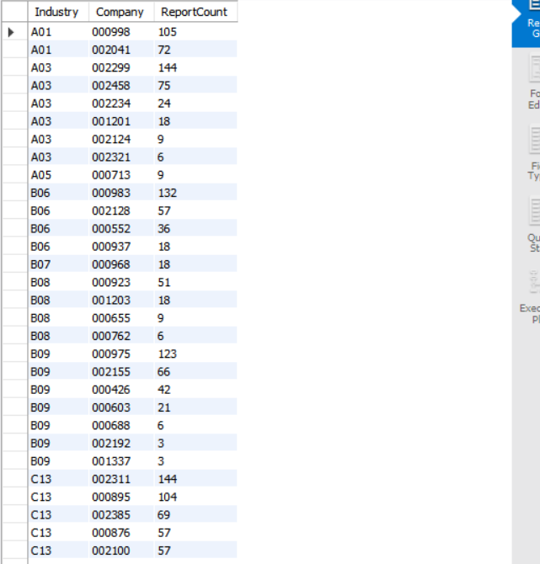

1. How many companies and how many industries are covered by each brokerage firm in 2023?

**Code：**

CREATE VIEW Brokern_count1 AS

SELECT

af.Brokern AS Broker,

COUNT(DISTINCT af.Stkcd) AS CompanyCount,

COUNT(DISTINCT tc.Nnindcd) AS IndustryCount

FROM

af_forecast2 af

JOIN

trd_co2 tc ON af.Stkcd = tc.Stkcd

WHERE

YEAR(STR_TO_DATE(af.Rptdt, '%Y/%m/%d')) = 2023

GROUP BY

af.Brokern;

select * from Brokern_count1

**Result**

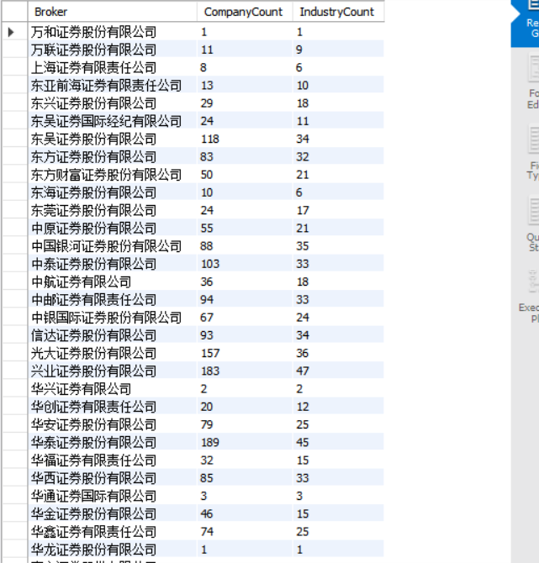

1. Show a list of forecasted earnings per share (Feps) for 比亚迪 (002594) by each brokerage firm at the end of 2023 (Note: choose Fenddt = 2024-12-31, choose the last Rptdt in year 2023 for each brokerage firm)

**Code:**

CREATE VIEW forecasted_earnings (Stkcd, InstitutionID, Brokern, Feps) AS

SELECT

Stkcd,

InstitutionID,

Brokern,

Feps

FROM

af_forecast2

WHERE

Stkcd = '002594'

AND Fenddt = '2024/12/31'

AND Rptdt = (

SELECT MAX(Rptdt)

FROM af_forecast2 AS sub

WHERE sub.InstitutionID = af_forecast2.InstitutionID

AND STR_TO_DATE(sub.Rptdt, '%Y/%m/%d') BETWEEN STR_TO_DATE('2023-01-01', '%Y-%m-%d') AND STR_TO_DATE('2023-12-31', '%Y-%m-%d')

);

Select * from forecasted_earnings

**Result:**

**文本

**